A000-Afr-Gabon-Kota peoples-Mahongue Group-Reliquary Ensemble-Mid 19th c

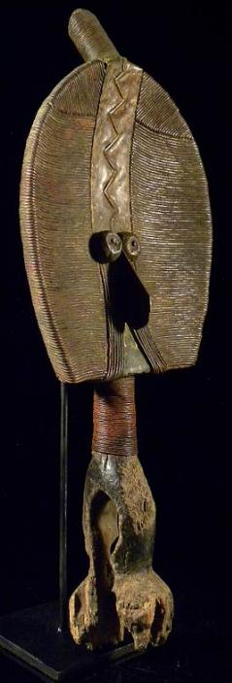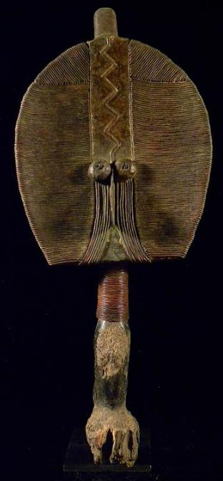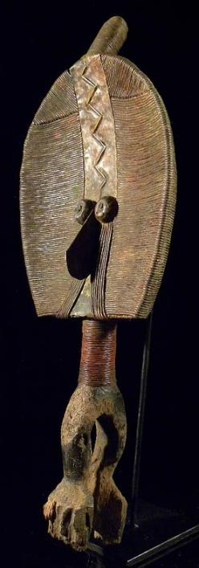

Afr-Gabon-Kota peoples-Mahongue Group-Reliquary Ensemble-Mid 19th c

Case No.: 6

**Accession No.**

**Formal Label:** Afr-Gabon-Kota peoples-Mahongue Group-Reliquary Ensemble-Mid 19th c

**Display Description:**

This type of a Kota reliquary ensemble was the first example to be recognized in Europe as a major tradition of reliquary sculpture that had been developed in eastern Gabon. A similar specimen was collected by Oskar Lenz, an explorer and geologist of Leipzig, who made several trips to the Upper Ogooue River from 1874 to 1876 as a member of the Deutsche Gesellschaft zur Erforschung Aqua­torialafrikas. When he donated his specimen to the Museum für Volkerkunde in berlin in 1875, he referred to it as a "fetish-idol" of the "Aduma" and "Oschebo" peoples of the Middle Ogooue River (Siroto 1968: 24). However, Leon Siroto has attributed these specimens to peoples located between the eastern tributaries of the Lower Ivindo River: the Shake, BoNgom, and Ndambomo groups (Kele-speaking peo­ples) and the Mahongwe, BuSamai, and Kota groups (Kota-speaking peoples) (Siroto 1968:89).

In the Kota, Mahongwe, and Shamaye devotional cult dedicated to the ancestors, the relics conserved and vener­ated by members of a clan and the figural artifact accom­panying them were all referred to as bwete(Perrois 1969, p. 9.) The highly abstract Mahongwe representations are distinctive for their construction, which encases a wood core within an allur­ing brass sheath. These are often described as "foliate," given their flattened leaf-like configuration. While the design is relatively two-dimensional, it is subtly modulated by the play between the concave face and convex base, established by the carved-wood understructure, and by the shifting surface textures of the applied metals. The shape of the head is ovoid, with a straight lower edge. The head is surmounted by a cylindrical extension encased in brass wire that is positioned at a forty-five-degree angle. According Louis Perrois, this feature represents a thick braid, called i-benda, worn by notables in a traditional hairstyle known as bakani (Perrois and Siroto 1969, p. 67)

A broad median band extends from the upper rim to the bridge of the beaklike nose, made from a projecting brass element. The facial features are all concentrated at its base and are aligned with this axis. One of the two applied circular metal eyes—the proper left—is missing in early photographic records and has since been replaced (Siroto 1968, p. 87, fig. 8). The nose is flanked by a pair of bands, composed of a series of wire filaments, that extend below the eyes and curve out to the rim of the chin. On either side of the central axis, the surface is covered with carefully applied cut-metal bands that create a succession of horizontal striations. The cylindrical neck echoes the form of the coiffure at the sum­mit and is also wrapped in brass wire. The lower part, an ovoid perforated at the sides, is covered with brass sheet­ing enhanced with repoussé designs. Ancestral relics were bound within a packet or basket that was tied to this base, hence this is terms a sculptural element of the whole reliquary.

In particular about this specimen, it is considered among the finest of its kind for its physical breadth and the artistry of its construction. When the work is compared with the example, collected by Oskar Lenz, a series of striking and subtle distinctions are apparent. Not only is the width of the head greater in expanse, but the filaments that extend horizontally across the surface are not as flattened, affording the work greater surface contrast. Another distinc­tion lies in the manner in which the tips of those filaments are integrated into the decorative scheme of both the front and back sides, to very different ends. The virtuosity of the metalwork is apparent on the front, where the folded fila­ment tips form a delicate seam along either side of the ver­tical axis in a manner reminiscent of fine needlepoint.

No mere two-dimensional frontal representation, the sculpture displays even more complex adornment on the reverse. Here the filaments have been wrapped around the edges so that their ends define an elegant alternating serrated border around the outer perimeter. At the center, aligned with and below the extension of the chignon, is a median axis composed of two parallel raised ridges that span the entire length of the back. On either side are bilat­erally symmetrical repoussé designs of a series of concen­tric triangles that reach to the outer edges. These densely stippled graphic patterns afford the work another textural dimension. Directly below the striated coiled neck, the plated surfaces of the base are embossed with a network of lozenges.

**LC Classification:**

**Date or Time Horizon:**

**Geographical Area:**

**Map:**

**GPS coordinates:**

**Cultural Affiliation:**

**Media:** Wood, copper, brass, fiber.

**Dimensions:** 21 inch / 53 cm,

**Weight:** 1,8 kg

**Condition:**

**Provenance:**

**Discussion:**

In Mahongwe society such works were assigned guardianship of relics derived from singularly important individuals. According to Louis Perrois, the candidates worthy of contributing relics included not only a clan's most distinguished male leaders but also mothers of an exceptional number of children or of twins, the latter being associated with prosperity and good fortune (Perrois 1969: 11). Leon Siroto notes that those who distinguished themselves were perceived to be invested with mystical powers that inhered in their skulls following their death. Close relatives in turn retained these as a means of positively influencing the affairs of their extended family (Siroto 1968, :22-23). The foliate figure that surmounts the relic was intended to deflect any adversaries from interfering with its power (Siroto 1968,: 86).

Such works were also taken out of seclusion by clan leaders and deployed in village rites in response to signifi­cant crises such as the death of a communal leader, the approach of an epidemic, or the launch of a dangerous hunting expedition. In order to intensify their potential to address these concerns effectively and fortify the commu­nity on such occasions, all the reliquaries of a village were brought together in the belief that their combined power constituted a formidable protective barrier and an impene­trable shield (Siroto 1968: 27).

**References:**

Perrois, Louis. 1969. *Le Bwété des Kota Mahongwe du Gabon: note sur figures fueneraires des populations du bassin d'Ivindo*. Libreville: OSTROM.

Perrois, Louis. 1969. Notes on the Bwuiti figures: response to Leon Siroto's article, 'The face of the Bwiti.'

Siroto, Leon. 1969. Author's reply, *African Arts* 2 (no. 4),: 65-69.:

Siroto, Leon. 1969. Masks and social organization among the Bakwele people of western equatorial Africa. Ph.D. diss. New York: Columbia University.

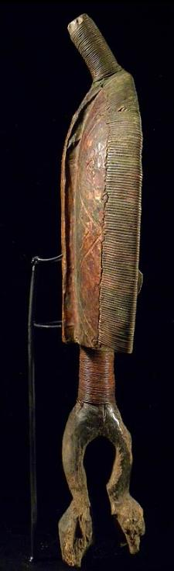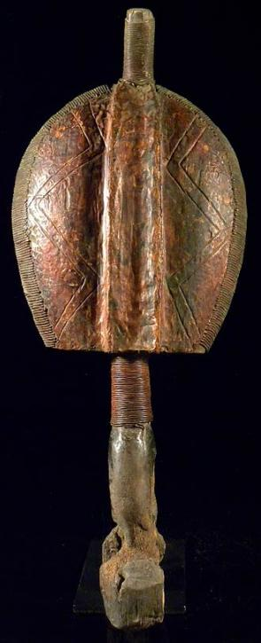 SHAPE \* MERGEFORMAT 